**Manual**



University of Management and Technology

Group: Muneeb, Saad, Asad, Mishkat, Inza

Id: 21016020-010, 18, 53

Instructor:Ma’am Fatima Khalil Butt

Course Title: Information Security

Course Code: CC3121

Department: Bachelor of Computer Science

Information Security

**Aircrack-ng**

**Table of Contents**

**Introduction:** 3

**Installation Steps:** 3

**Tool Use Cases:** 3

**Use Case 1:** 3

**WIFI Password Cracking using aircrack-ng:** 3

**OSI Model Layer Mapping:** 16

**MITR ATT&CK Mapping:** 16

**Mitigation Strategies:** 17

**References:** 17

# **Introduction:**

**Purpose:**

Aircrack-ng is a powerful network security toolset primarily used for auditing Wi-Fi networks. Its main purpose is to evaluate the strength of wireless encryption protocols such as WEP, WPA, and WPA2 by attempting to crack their passwords. Among these, WPA2 is the most commonly targeted due to its widespread use. To crack WPA2, a four-way handshake must be captured. This handshake occurs during the authentication process between a client and a Wi-Fi access point and operates under the EAPOL (Extensible Authentication Protocol over LAN) framework. Once captured, this handshake can be used in offline attacks such as dictionary or brute-force attacks to attempt to recover the Wi-Fi password.

**Key Features:**

* **Network Scanning**: Scans for nearby wireless networks and displays details such as MAC addresses (BSSID), ESSID (Wi-Fi name), channel, and encryption type.
* **Handshake Capture**: Captures the 4-way handshake needed to crack WPA/WPA2 passwords.
* **Password Cracking**: Cracks WEP and WPA/WPA2-PSK keys using dictionary/brute-force attacks (aircrack-ng).

**Relevance in Cybersecurity:**

Aircrack-ng is highly relevant for:

* **Penetration Testing**: Used by ethical hackers to find and fix vulnerabilities in wireless networks.
* **Security Auditing**: Helps network administrators test the robustness of their Wi-Fi security.
* **Educational Purposes**: A great tool for learning wireless protocols and security concepts.

# **Installation Steps:**

# **Tool Use Cases:**

## **Use Case 1:**

## **WIFI Password Cracking using aircrack-ng:**

**Step1:** Check the wlan0 mode. It shows the mode(manage).

**iwconfig:** This command lists all wireless interfaces and their current modes. Look for interfaces like wlan0 to identify your wireless adapter.

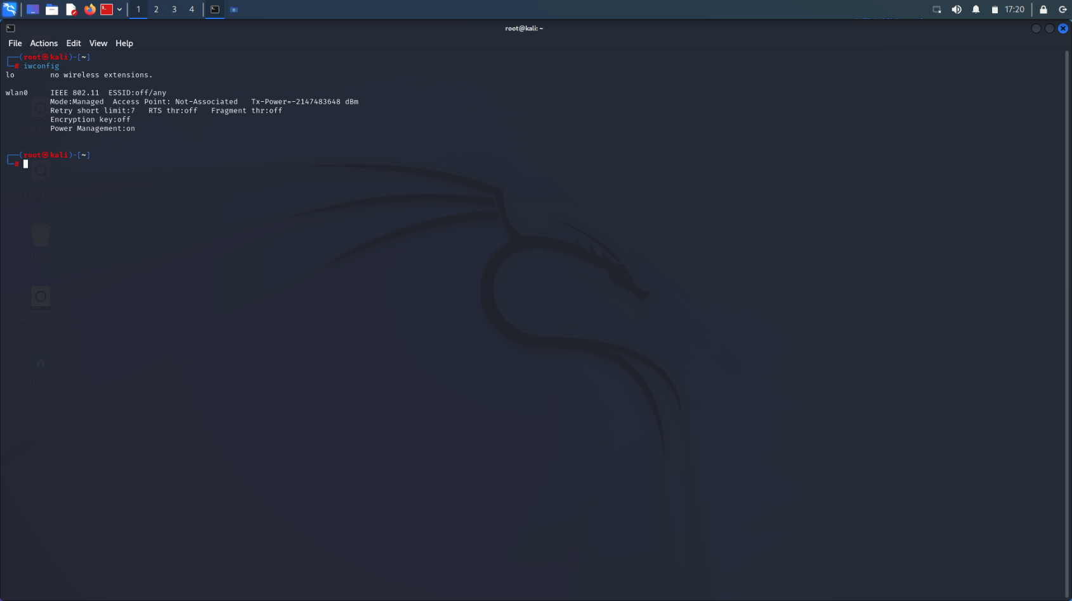

**Step2**: Change the manage of wlan0mode to monitor mode. We are using a tool (airmon –ng).

**airmon-ng –help**: airmon-ng is a script that simplifies enabling and disabling monitor mode

on wireless interfaces. It also helps detect and manage processes that may

interfere with packet capture and injection.

**Sytnax:** Usage: airmon-ng <start|stop|check> <interface> [channel or frequency]

**Options:**

* + Start:Start monitor mode on an interface
  + Stop:Stop monitor mode on an interface
  + Check: Check for processes that might interfere with monitor mode

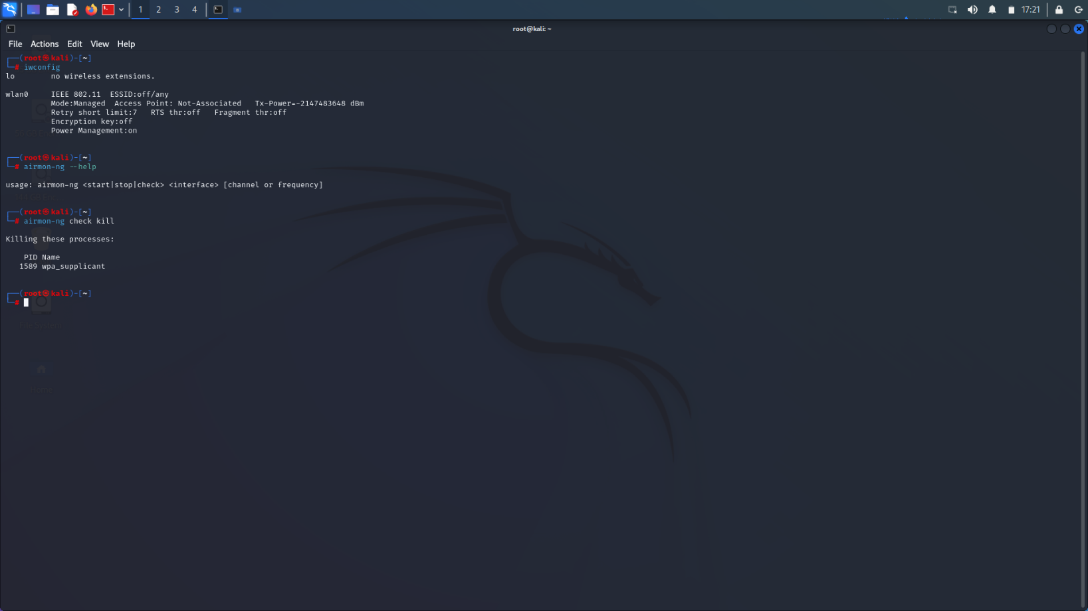

**Step3:** Before enabling monitor mode use the following command.

**airmon-ng check kill**: This command detects and kills background processes that can interfere with WiFi monitor mode and packet injection.



**Step4**: Enable /Starting monitor mode for wlan0.

**airmon-ng start wlan0:** This command is used to start monitor mode on your Wi-Fi adapter (wlan0) using the airmon-ng tool.

* We again use iwconfig command to check if it is changed to monitor mode.

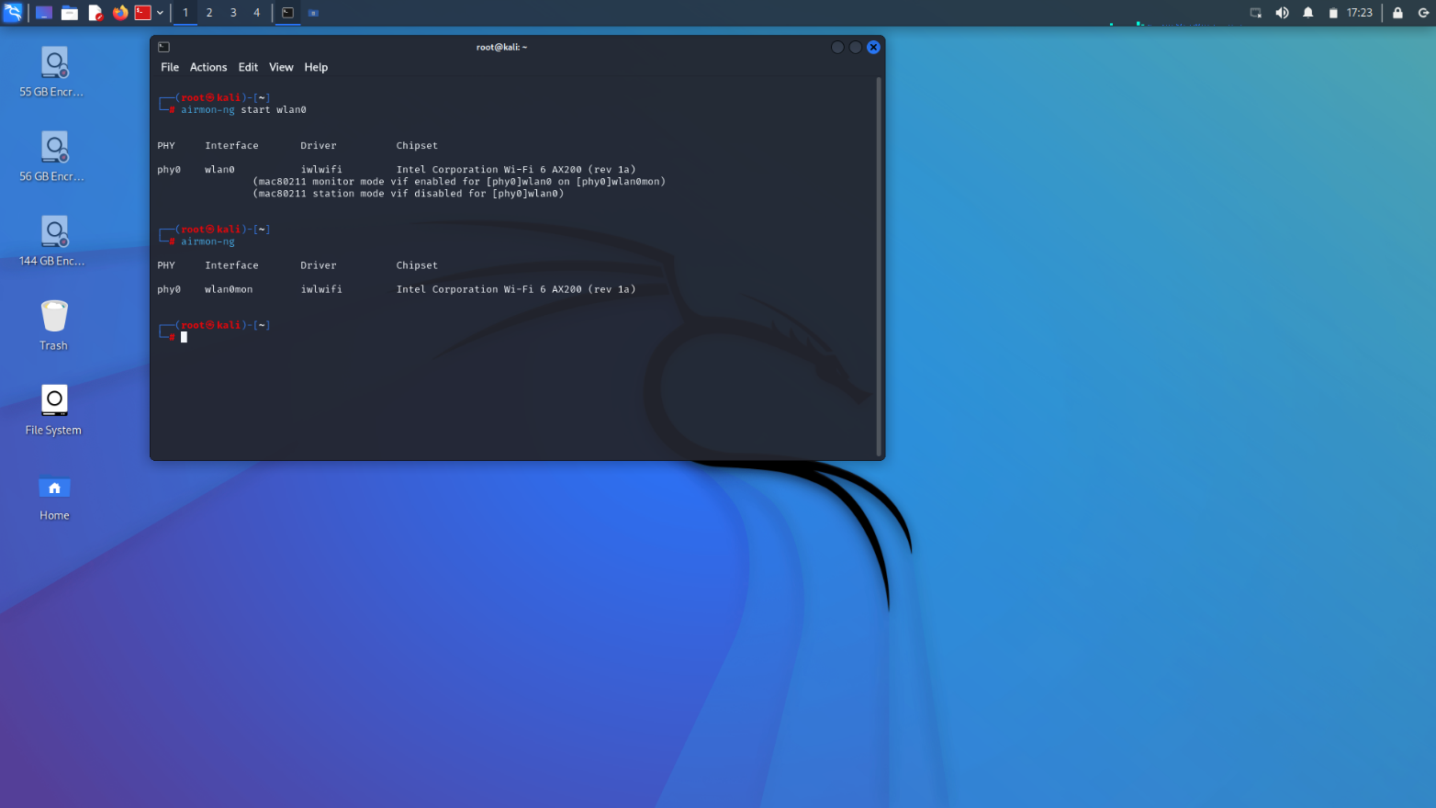

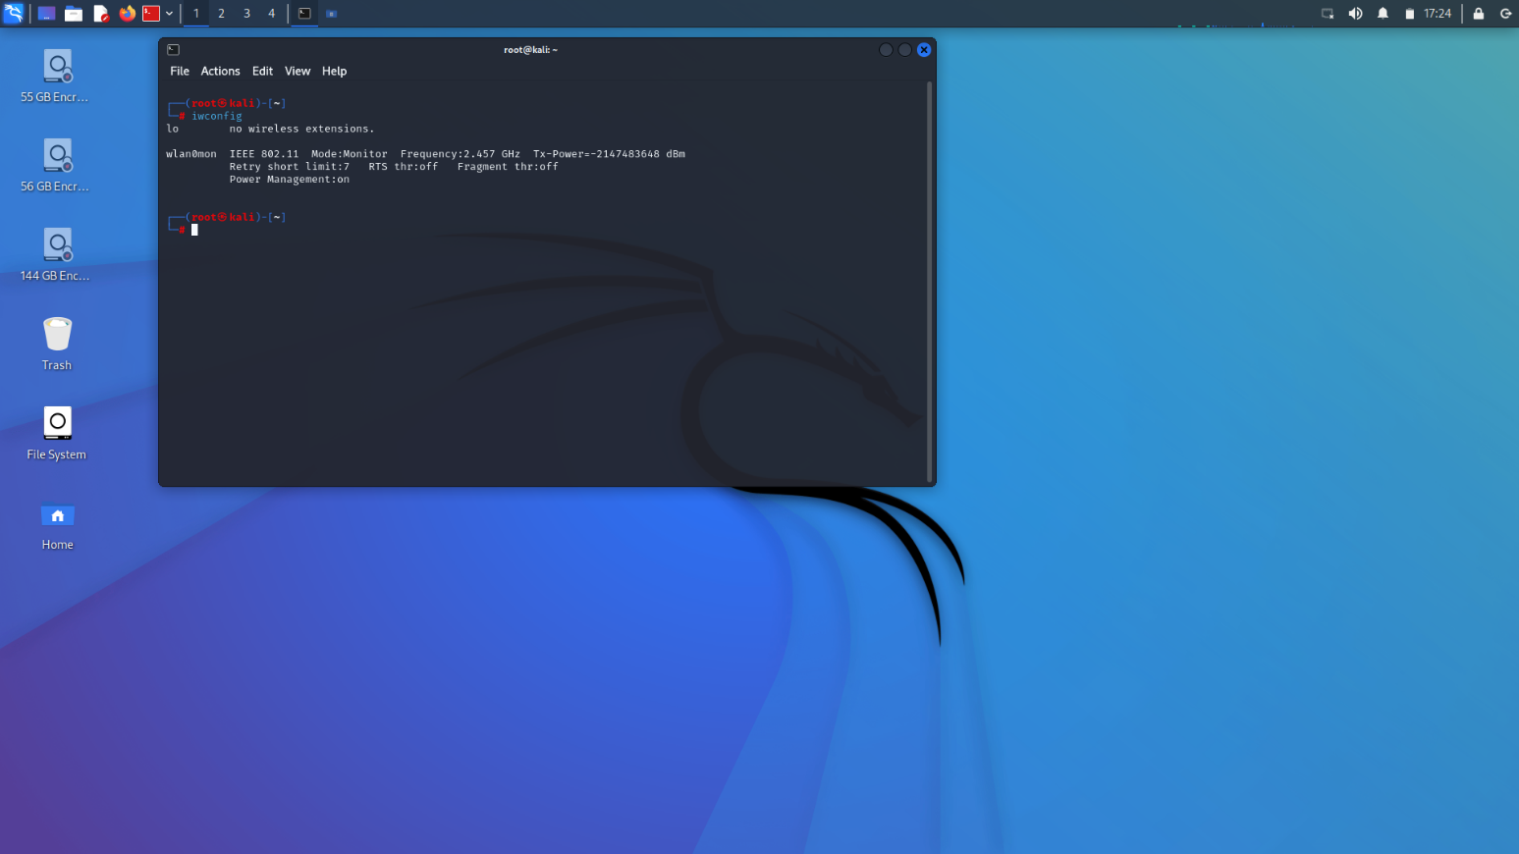

**Step5**: Check which access points are being detected. After detecting have to check their BSSID.

**airodump-ng wlan0mon:** This command is one of the most important steps in WiFi pentesting, used to scan nearby WiFi networks and show all the access points (APs) and connected devices. Note the BSSID and channel (CH) of the target WiFi network.

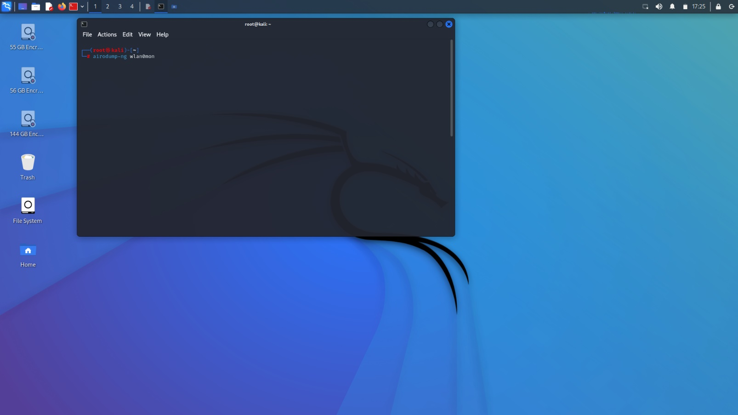

**Step6:** Target a specific network. Monitor a particular access point.

**airodump-ng wlan0mon -c <CH> --bssid<Target-Mac>:** This command is used in WiFi pentesting to focus only on one target WiFi access point (AP) instead of scanning all the networks. This is often done before trying to capture the WPA/WPA2 handshake.

**UseCase1:**

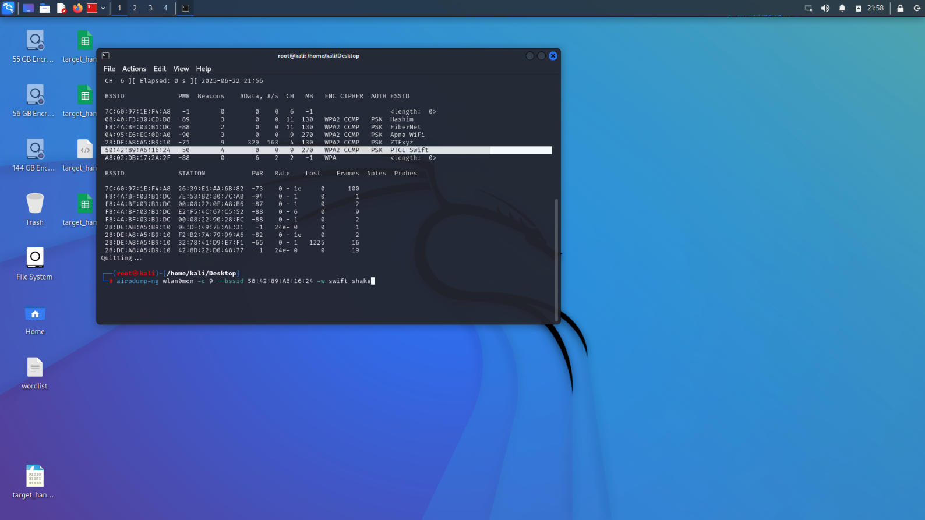

**UseCase2:**

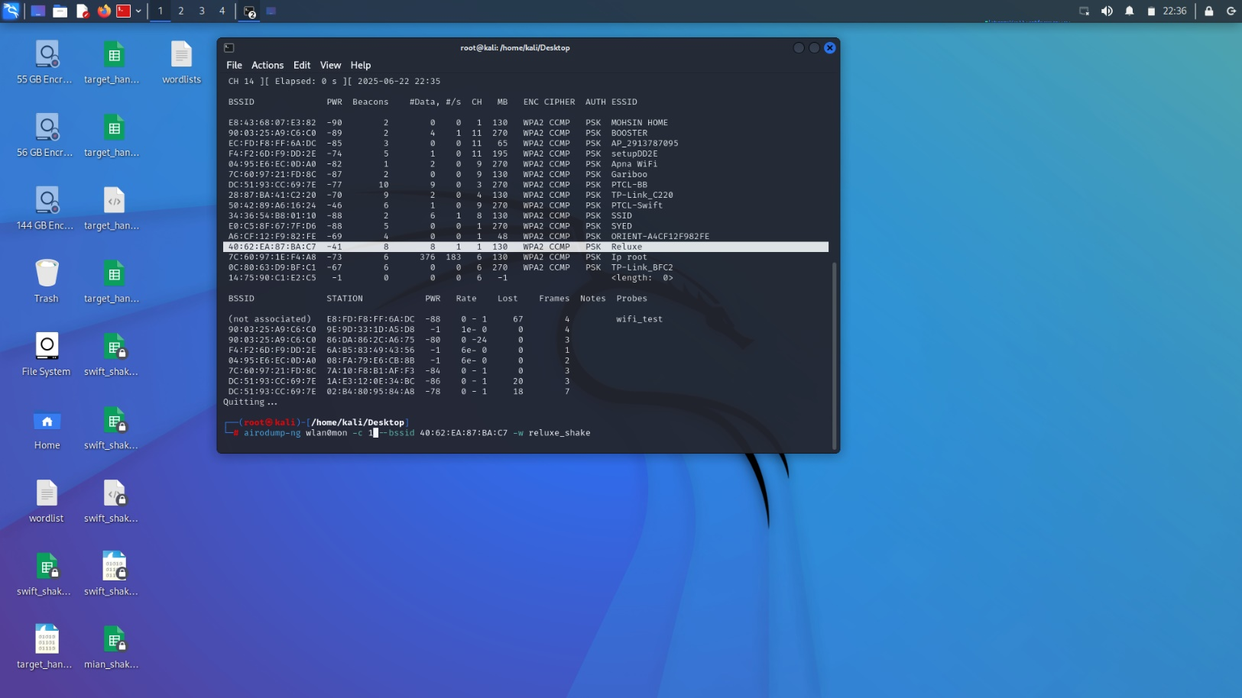

**Step7**: Perform wi-fi deauthentication attack, for this disconnect target device after reconnecting it handshake will be captured.

**airodump-ng wlan0mon -c <CH> --bssid<Target-Mac> -w target-handshake**: Lock onto the target WiFi using its channel and BSSID it can capture traffic. Then we wait for a device to connect or reconnect to that WiFi. When it does, the WPA/WPA2 handshake is captured, which is needed later to crack the WiFi password.

**UseCase1:**

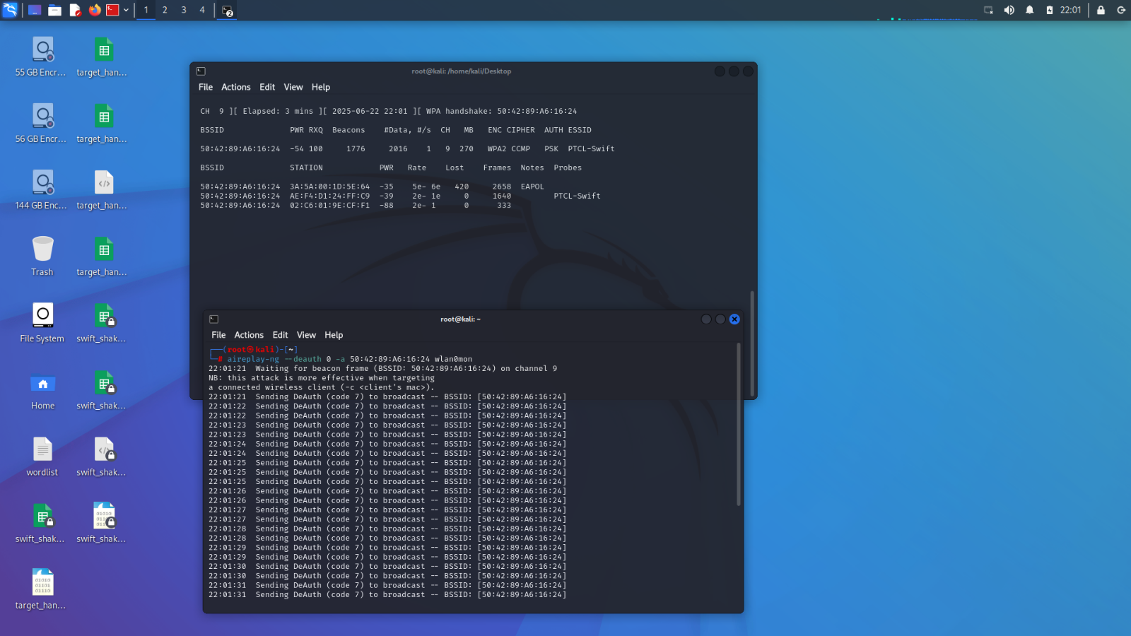

**UseCase2:**

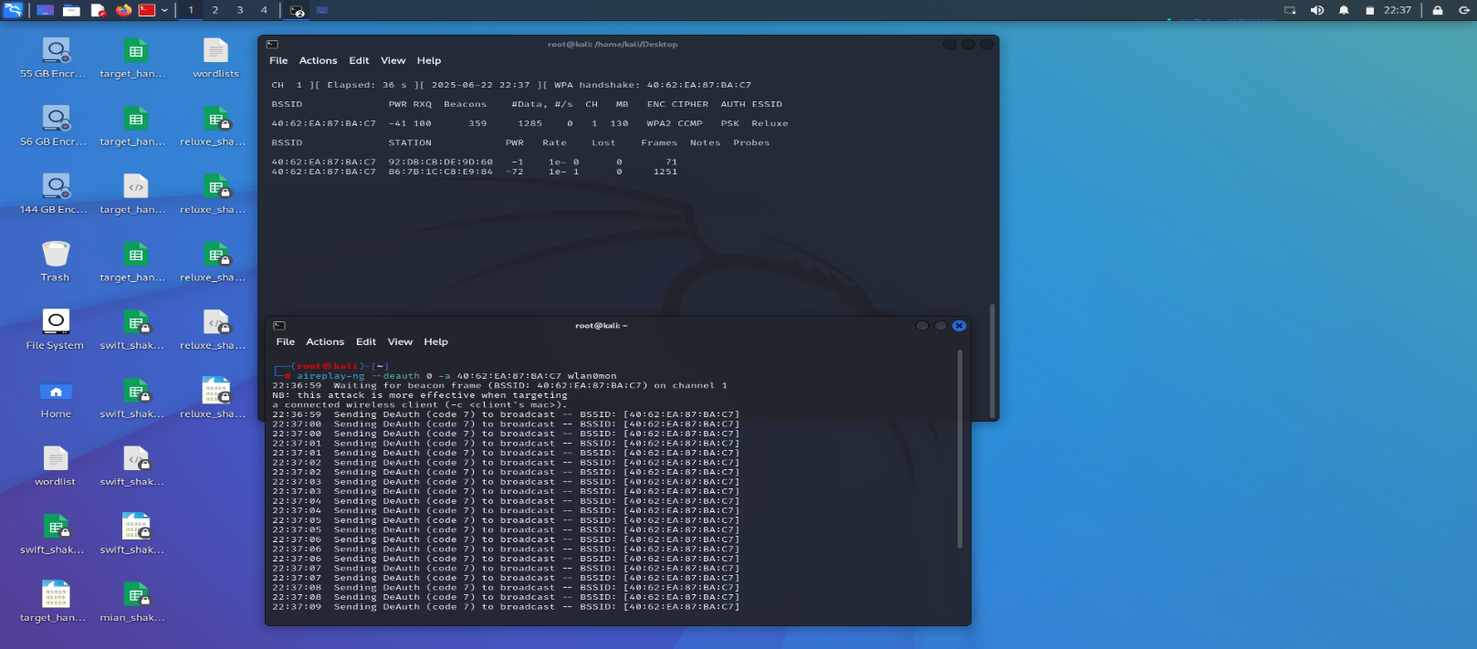

**Step8:**Start deauthentication attack. Firstly check all the available option use for deauthentication attack. Deauthenticate a client to capture handshake.

**aireplay-ng –help:** This command displays all the available options and usage examples for the aireplay-ng tool which is used to inject packets into a network, including performing deauthentication attacks to disconnect clients.

**aireplay-ng --deauth 10 -a [Target_BSSID] -c [Client_MAC] wlan0:** This forces the client to disconnect and reconnect, during which the handshake can be captured.

**UseCase1:**

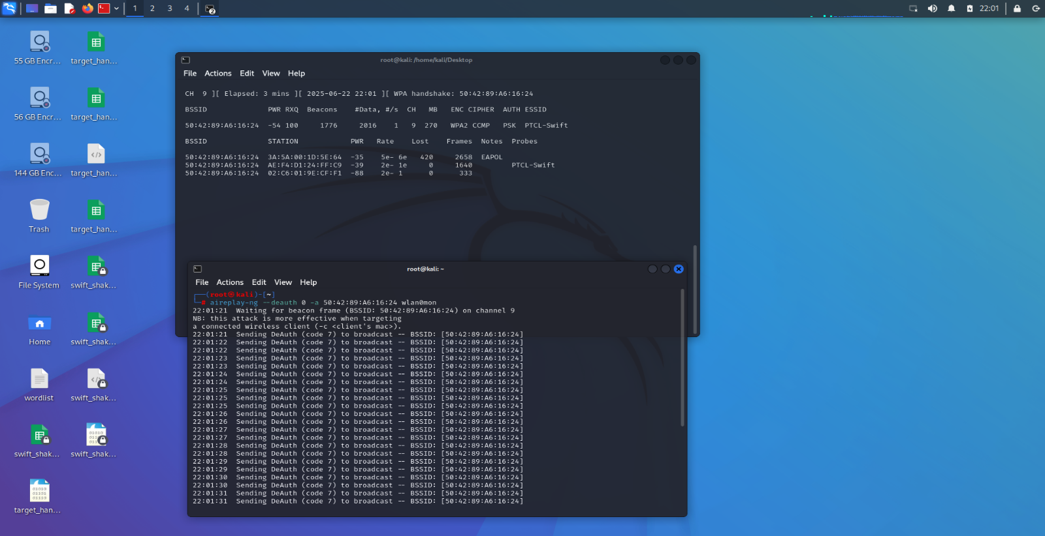

**UseCase2:**

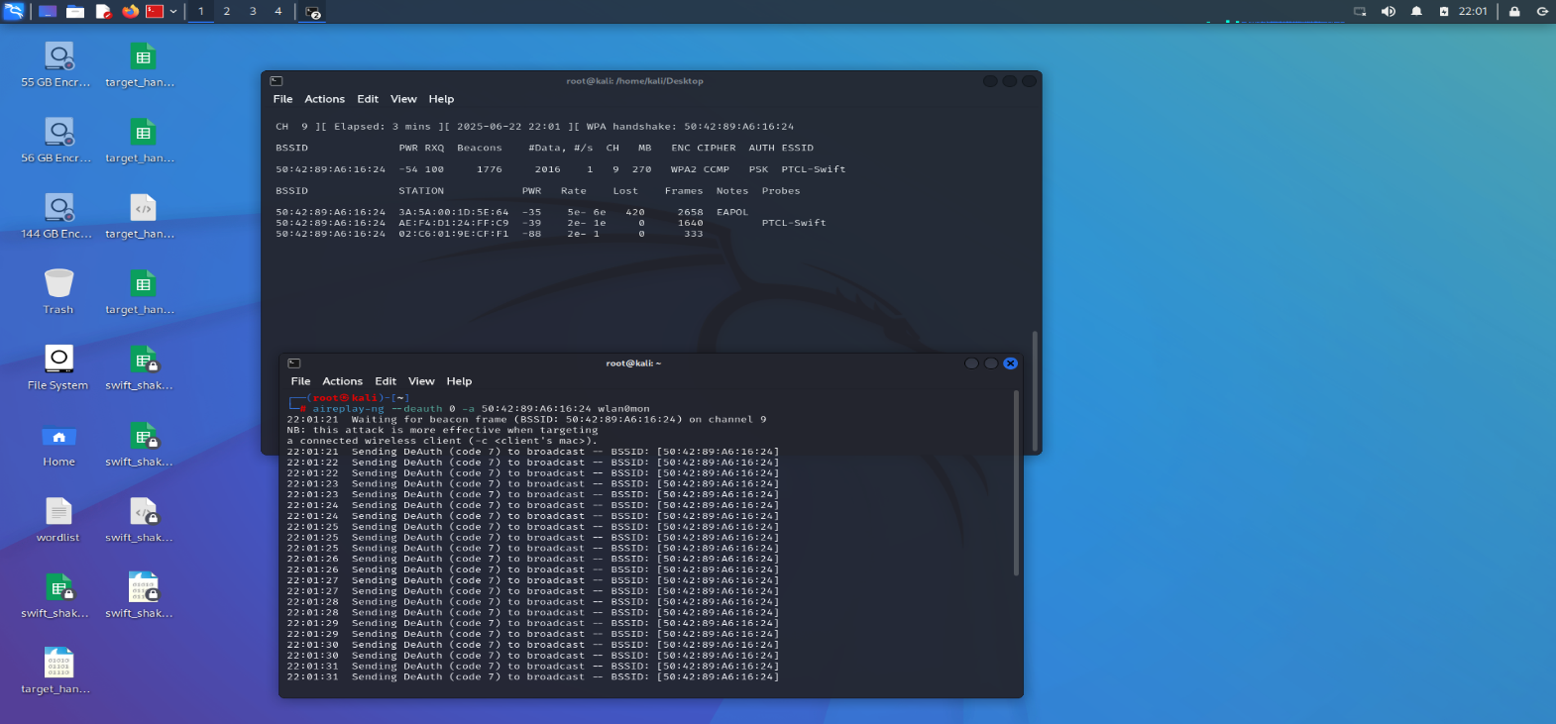

**Wordlist:**

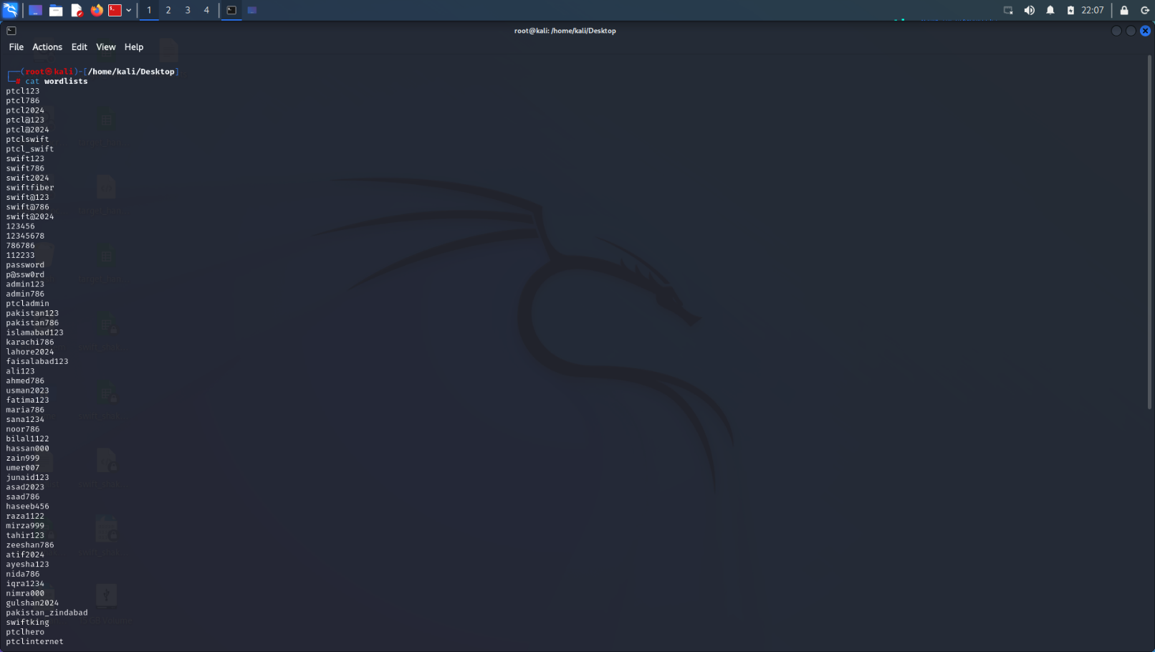

**UseCase2:**

**Step10:** Key is found.

**aircrack –ng –w wordlist.txt handshake.cap:** It is used to crack Wi-Fi passwords captured during a handshake between a device and a wireless access point.

**UseCase1:**

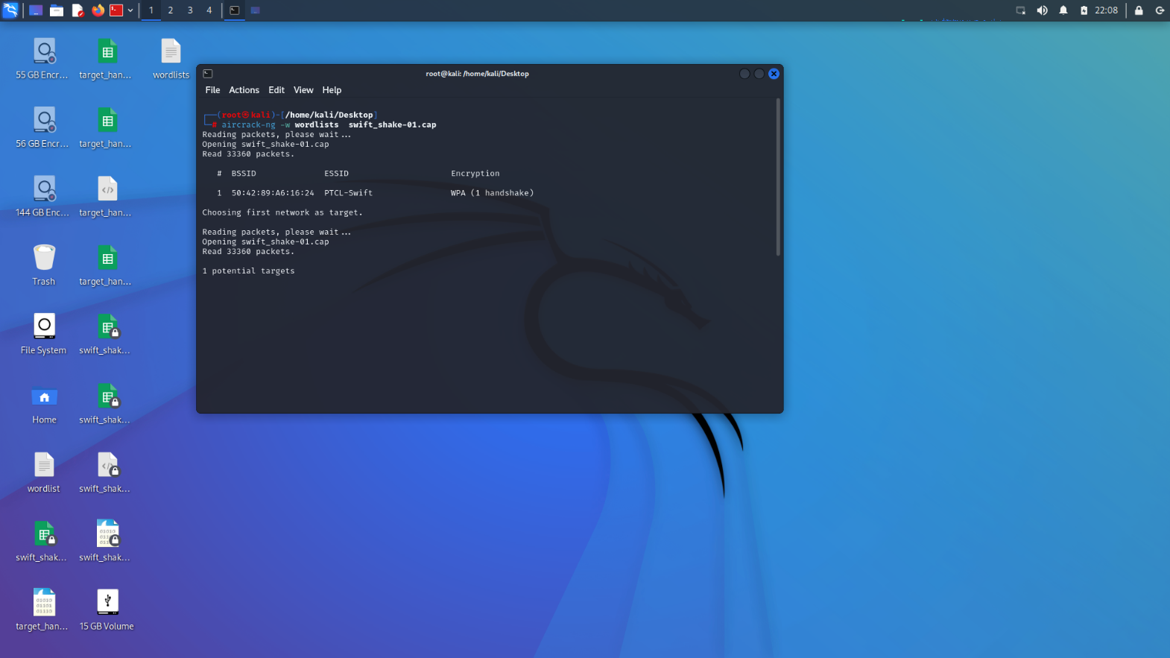

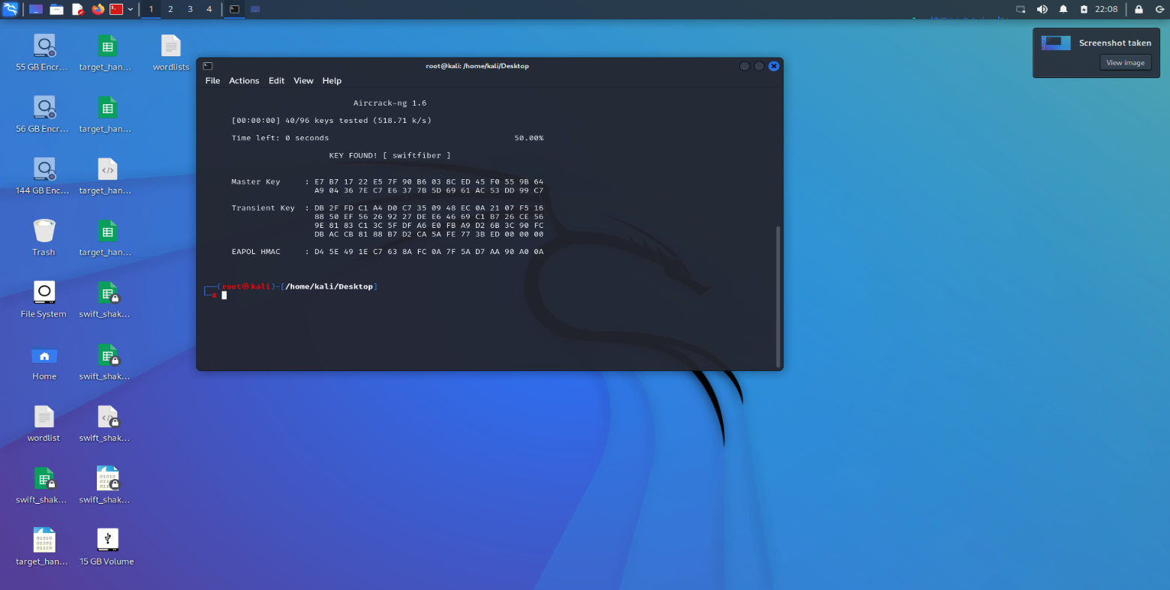

**UseCase2:**

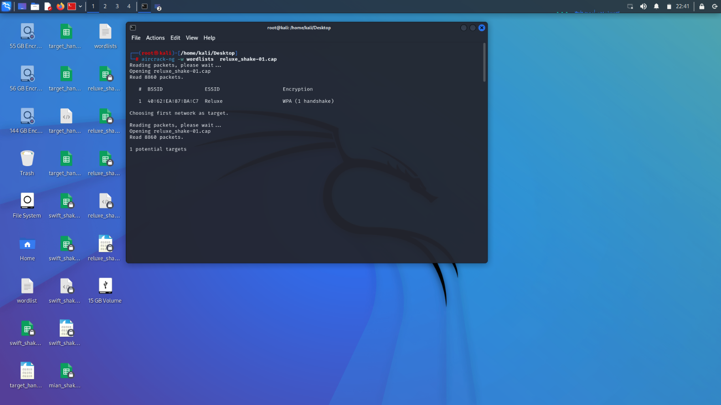

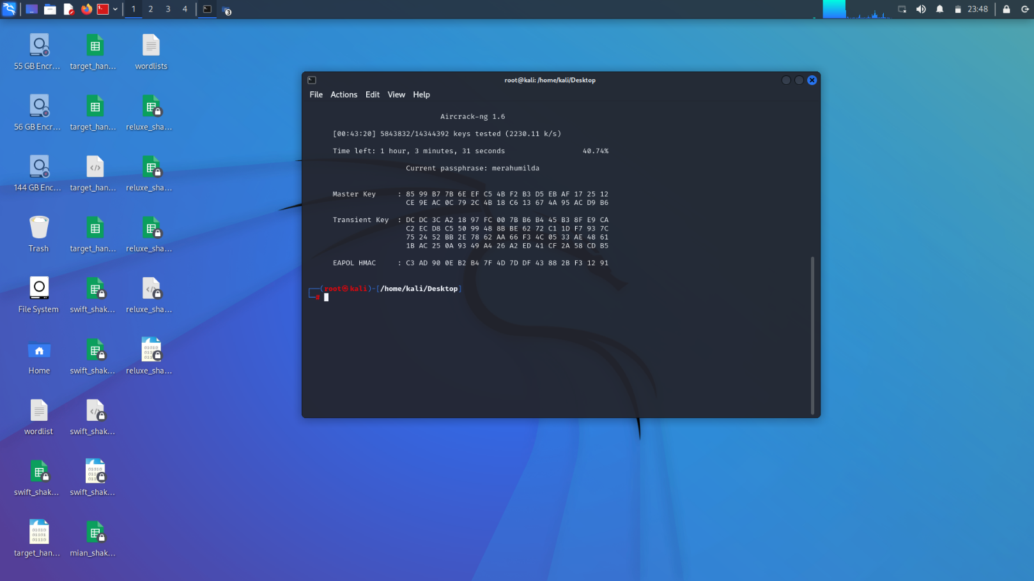

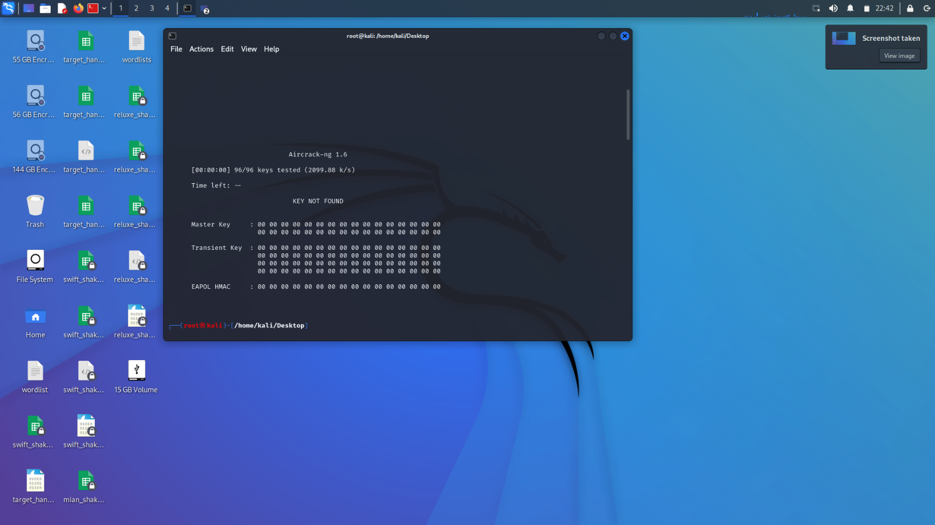

**Step11**: Stop the monitor mode. Using iwconfig we can check the mode.

**airmon-ng stop wlan0mon:** It is used to stop monitor mode on your wireless interface.

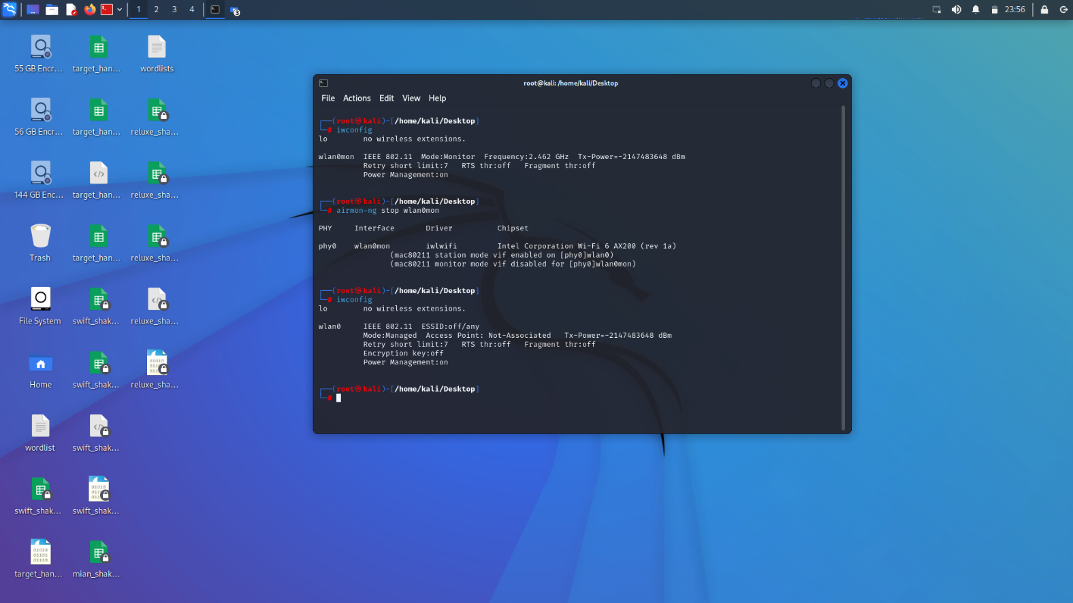

**Step12:** Start network manager it controls wifi-adapter.

**service network-manager start:** Start or restart your system's network management service, so that it can automatically handle your Wi-Fi, Ethernet, VPN, and other network connections.

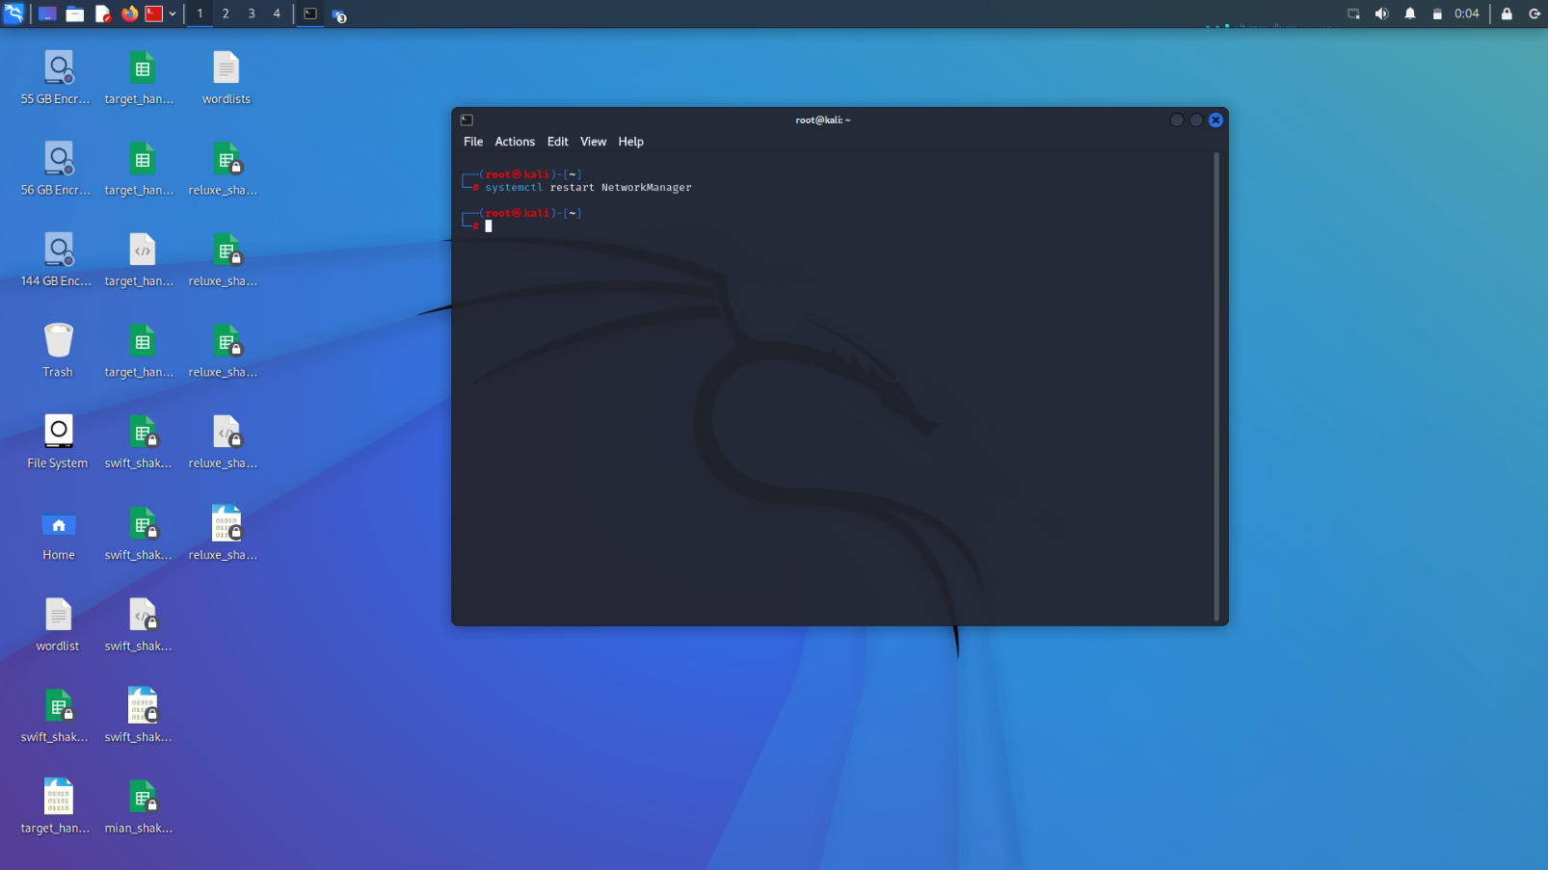

**Step13:** Check if the entered password is working or not.

**ping google.com**: It is used to check if your internet connection is working and to test network reachability.

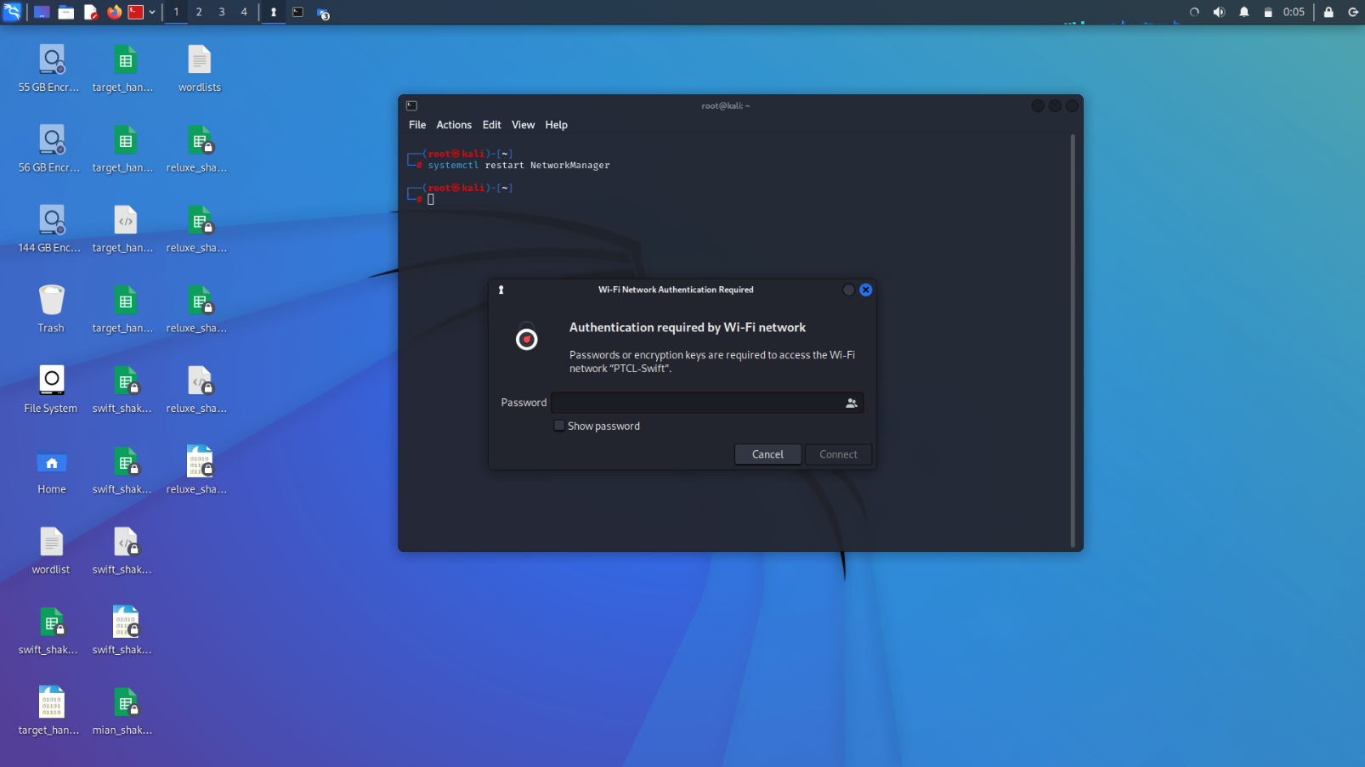

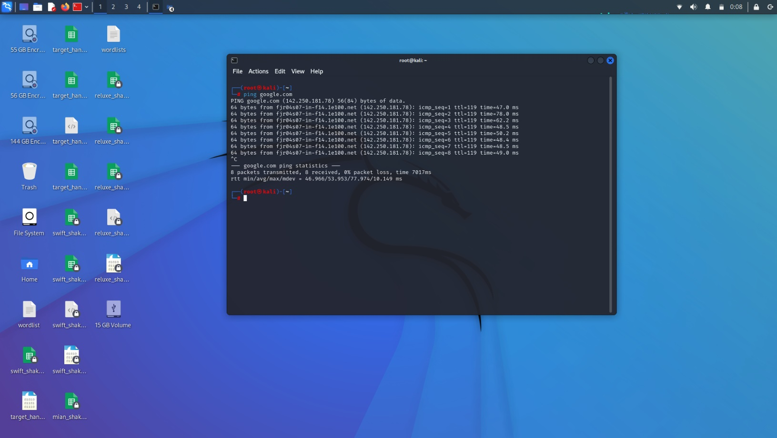

# **OSI Model Layer Mapping:**

|  |  |  |
| --- | --- | --- |
| **Tool** | **OSI Layer** | **Role in Security** |
| Aircrack-ng | Physical Layer | Capturing Wi-Fi handshakes and testing wireless network security. |

# **MITR ATT&CK Mapping:**

|  |  |  |  |  |
| --- | --- | --- | --- | --- |
| **Tool** | **Tool Feature** | **Description** | **MITRE Tactic** | **Technique ID** |
| airodump-ng | Wireless Network Discovery | Scans and displays SSID, BSSID, channel, encryption type of nearby networks. | Reconnaissance | T1590.002 |
| airodump-ng | Handshake Capture | Captures WPA/WPA2 4-way handshake packets for offline password cracking. | Credential Access/Collection | T1040 |
| airodump-ng | Device Discovery | Monitors a specific router to identify connected devices. | Discovery | T1018 |
| aircrack-ng | Password Cracking | Cracks WPA/WPA2 password using a wordlist and captured handshake. | Credential Access | T1110.001 |

# **Mitigation Strategies:**

|  |  |
| --- | --- |
| **Mitigation Strategy** | **Description** |
| Use Strong Encryption (WPA3) | Upgrade to WPA3 to resist brute-force and dictionary attacks. |
| Regularly Change Wi-Fi Passwords | Change passwords periodically to reduce risk of long-term compromise. |
| Monitor Wi-Fi Access Logs | Regularly check who is connecting and at what times. |
| Enable MAC Address Filtering | Allow only known devices by filtering their MAC addresses. |
| |  | | --- | |  |  |  | | --- | | Detect Deauthentication Attacks | | Use tools or routers that can identify and block disconnect (deauth) attempts. |

# 

# **References:**

* **Aircrack-ng Documentation:** <https://www.aircrack-ng.org/>
* **MITRE ATT&CK Framework:** <https://attack.mitre.org/>
* **Linux Commands Guide:** <https://linux.die.net/>
* **YouTube Video Reference:** <https://youtu.be/rBg7ExjJ-BA?si=FxMXAoGQVMzN21du>
* **GeeksforGeeks – Understanding WPA/WPA2 4-Way Handshake:** <https://www.geeksforgeeks.org/linux-unix/capture-handshake-address-with-airodump-ng-and-aireplay-ng/>